Synopsis:

Currently we want to use Scalene-- which excels by:

- Line-by-line profiling of CPU, memory, and GPU usage.
- Differentiates between Python vs. native code execution.
- Estimates energy consumption based on CPU/GPU time.
- Identifies memory leaks and inefficient allocations.

Limited by:

- No direct power measurement: Estimates energy but does not read power sensors.
- Python-only focus: Cannot profile deep learning backends in C++ (like TensorFlow, PyTorch CUDA).
- Lack of fine-grained energy data: Does not capture power fluctuations in real time.?
- Cannot profile multiple processes: AI workloads involve multiple threads; Scalene focuses on the Python process.

What can we do?

CodeCarbon -- not specifically tracking hardware and runtime but making estimates based on historical data

is unique because it estimates the environmental impact of AI workloads rather than just profiling performance. It works by:

- Detecting CPU and GPU usage and estimating energy consumption.
- Using geographical data to determine the carbon intensity of electricity in different locations.
- Providing CO₂ emission estimates to help AI practitioners make energy-efficient choices.

Best Use Cases:
- Estimating the carbon footprint of training large ML models.
- Comparing energy consumption across cloud vs. local environments.
- Optimizing AI workloads to be more eco-friendly.

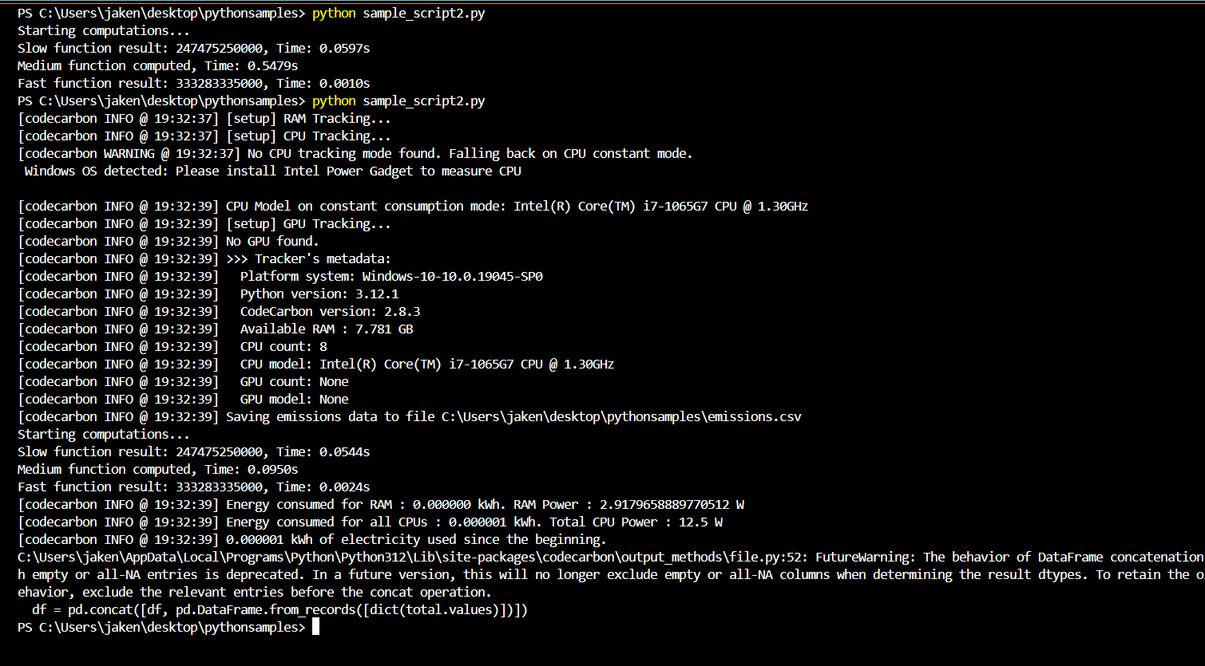

PyJoule:

Need windows subsystem for linux to run this as it needs low level hardware access:
- Intel RAPL
  - pyJoules uses the Intel "Running Average Power Limit" (RAPL) technology that estimates power consumption of the CPU, ram and integrated GPU.
- or NVIDIA API

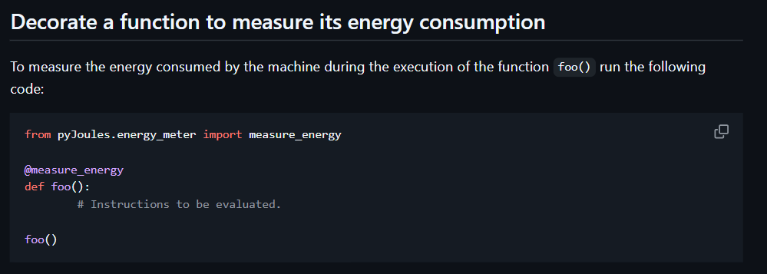

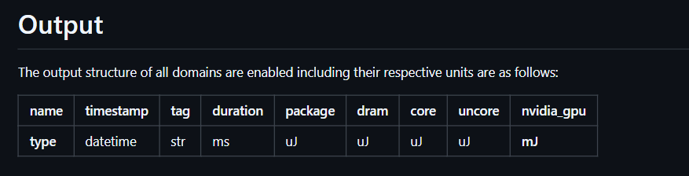

In my testing, evaluated CodeCarbon, PyJoules, and Scalene for energy profiling in AI workloads.

- CodeCarbon provides high-level energy and CO₂ emission estimates, making it great for tracking the environmental impact of models, but lacks fine-grained function-level insights.

-PyJoules, on the other hand, directly measures energy consumption using hardware power sensors like Intel RAPL and NVIDIA GPU APIs, allowing per-function energy tracking. However, PyJoules has limited Windows support, requiring Win Subsys Linux for accurate CPU power measurement.

-Scalene focuses on performance profiling, identifying slow or inefficient Python code while estimating energy usage indirectly through CPU/GPU time analysis.

Scalene and CodeCarbon can be used together for optimization and impact assessment.

Perun
- Measures energy consumption of Python scripts using Intel RAPL, ROCM-SMI, Nvidia-NVML, and psutil
- Monitor individual functions using decorators

Example of a perun report with benchmarking:
@monitor

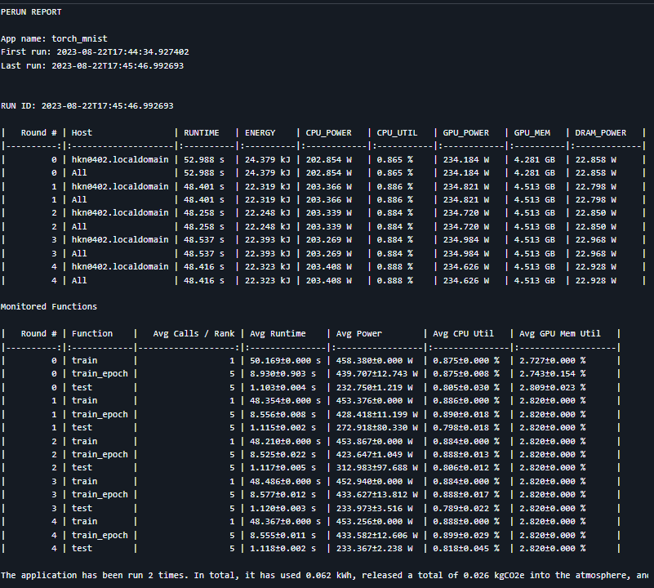

Not a great tool for windows

Recommendation -- Perun vs Scalene pros and cons:
Perun: Energy & Performance Versioning System
Best for: Tracking energy consumption over multiple executions and comparing different versions of a program.
Tracks:
- Energy usage (Joules, Watts)
- CPU & GPU power consumption
- Execution time & performance trends
Works with:
- Intel RAPL (CPU energy monitoring)
- Nvidia NVML (GPU energy tracking)
- AMD ROCM-SMI
Key Features:
- Tracks cumulative energy over multiple runs
- Works in distributed & MPI-based environments
- Stores historical energy usage for long-term optimization
Limitations:
- Requires hardware sensor access (not always available on Windows/VMs)
- Setup can be complex for function-level tracking

Scalene Performance Profiler
Best for: Code optimization by pinpointing bottlenecks in CPU, memory, and execution time.
Tracks:
- CPU usage (Python vs. C/C++ execution time)
- Memory allocation & leaks
- Estimated energy consumption (but not exact readings)
Works with:
- Any Python program
- No special hardware requirements
Key Features:
- Line-by-line profiling to identify energy-heavy functions
- Distinguishes between native vs. Python execution
- Estimates energy usage based on CPU time
- Limitations:
- Energy estimates, not actual power readings
- No built-in long-term tracking for energy efficiency

My recommendation: Scalene to optimize speed & memory, and Perun to track actual energy savings. -- might mean that we don’t have to fundamentally alter the scalene source code, rather use multiple tools in conjunction to gain a more well rounded view of what’s going on.

